NOVEXA – Six-Legged Hexapod Robot
A Pinnacle Robotics Project (First Year / First Semester)
Under the guidance of: Dr. Rabinder Henry
Faculty (3D Printing & CAD): Hetansh Visaria
Team: Aditiya Jadav | Archie Veera | Bilal Sabugar
Institute: Atlas SkillTech University – Department of Robotics
Academic Year: 2025–26

Abstract
This report details the design, fabrication, and implementation of NOVEXA, a 3D-printed, six-legged (hexapod) robot. The project explores bio-inspired locomotion through a multidisciplinary engineering approach. Each leg features three degrees of freedom (3-DOF), actuated by 18 high-torque MG995 servos, enabling complex kinematic motion, including a statically stable tripod gait. The system's architecture is centered on an Arduino Mega 2560 controller and two PCA9685 I²C servo drivers. A key innovation is the robust, dual-rail power distribution system, featuring independent 4S1P (servo rail) and 2S1P (logic rail) Li-ion battery packs, which eliminates motor-induced logic brown-outs. This report validates the design through rigorous testing methodology, including a calculated and verified ~20-minute operational runtime. The resulting platform is a scalable, cost-effective, and high-performance robot that lays a robust foundation for future work in advanced autonomy.

1. Conception
The conception of NOVEXA was driven by a specific engineering challenge: solving the critical power instability seen in many 18-servo hexapod builds. While the 3-DOF mechanics were well-established by the open-source community, our goal was to re-engineer the platform from the ground up, focusing on a clean, integrated design with dedicated spaces for all components, and, most critically, solving the power problem.
Our core concept was to engineer a robust, dual-rail power architecture from the outset, completely isolating the high-current 4S servo supply from the sensitive 2S logic rail. This would create a reliable and fault-tolerant foundation, not just a functional one.
This reliable foundation is essential for our long-term vision: to create an industry-ready platform capable of true autonomy. We are not stopping at simple remote control; the design was explicitly intended to support the future implementation of ROS, computer vision, and AI-driven gaits. Our goal is to create a robot that can see, navigate, and adapt to any situation. A platform capable of infinite possibilities.
To validate the mechanical feasibility and component fit of this integrated design, a 1:1 scale cardboard model was first used to verify all physical dimensions and clearances.
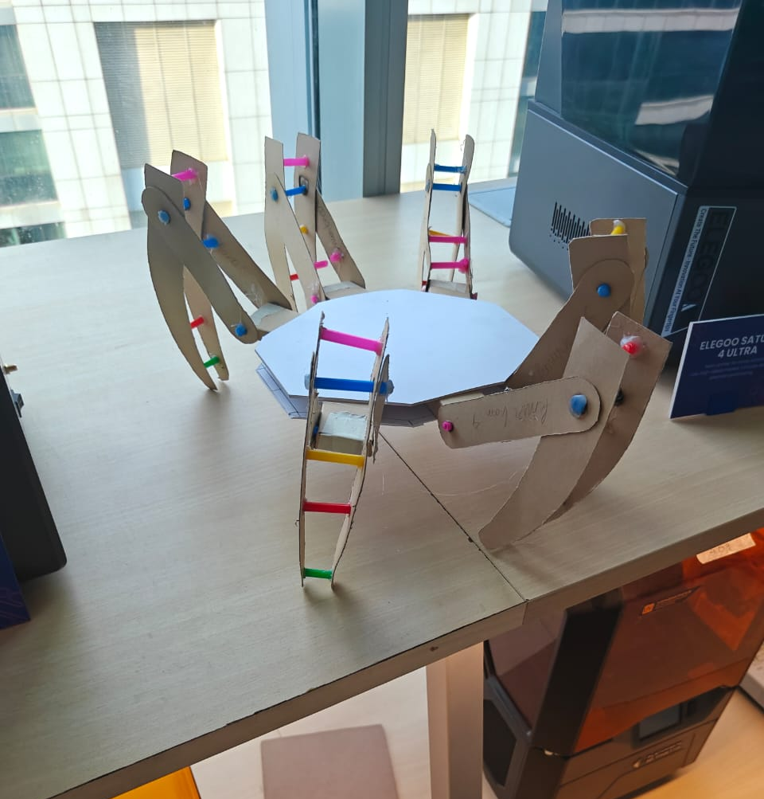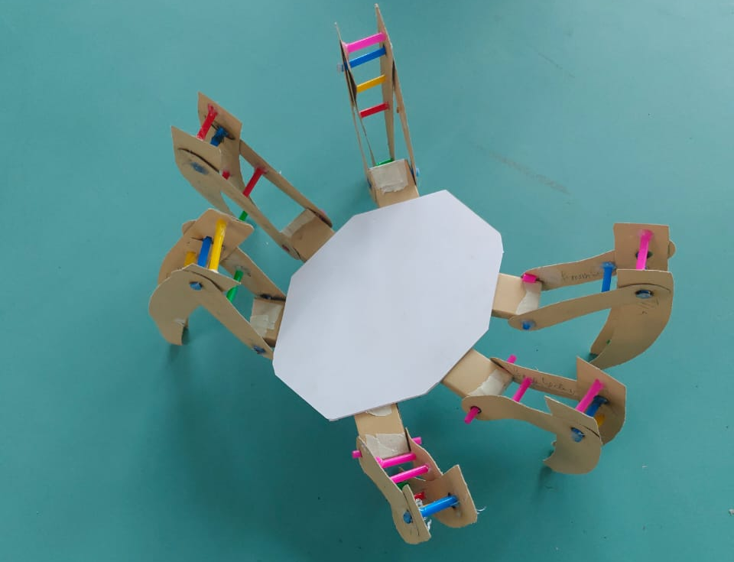

2. Introduction
The NOVEXA Hexapod is a six-legged robotic platform that explores bio-inspired locomotion principles while applying multidisciplinary engineering concepts such as mechanical design, embedded electronics, control algorithms, and additive manufacturing. Each leg provides three degrees of freedom (3-DOF): Coxa (yaw), Femur (pitch), and Tibia (pitch), actuated by high-torque MG995 servos. The system achieves static stability by maintaining at least three legs in ground contact during walking, following a tripod gait.
This report documents the complete technical development from theoretical modelling, design rationale, and electronics architecture to fabrication challenges, software implementation, and performance validation.

3. Literature Review and Project Positioning
The foundational design and kinematic principles of the NOVEXA project were heavily inspired by the open-source work of Aecert Robotics (Ryan Mirch)
https://www.youtube.com/watch?v=u-U2VmCW-e8&list=PL-XaVOMPsP-sUAtWbSIZ7vT40Ko2FEq-d
. His detailed YouTube series
https://github.com/Ryan-Mirch/Aecerts_Hexapod_V1
and public GitHub repository
With this foundation, NOVEXA's primary engineering contribution is its meticulously designed dual-rail power architecture. This system, with its isolated servo and logic power buses, directly solves the most common failure point in 18-servo hobbyist robots: logic-level brown-outs caused by servo current spikes. This robust design makes NOVEXA a highly reliable and powerful iteration, ideal for advanced academic development.

4. Design Rationale & Component Justification
This section justifies why specific components were chosen over common alternatives, detailing the engineering trade-offs.
4.1 Controller: Arduino Mega 2560
- Justification: The Arduino Mega was selected as the central controller for its high I/O pin count (54 digital pins), 5.0 V logic level, and mature, stable libraries. The 5.0 V logic interfaces directly with the PCA9685 drivers and MG995 servos without the need for level-shifting.
- Alternative Considered: A Raspberry Pi 4 was considered for its superior computational power, which would be necessary for future goals like ROS (Robot Operating System) integration. It was rejected for this project's scope due to the added complexity of its 3.3 V logic and the non-real-time nature of its Linux-based OS.
4.2 Actuators: MG995 Metal Gear Servos
- Justification: The 18-servo requirement demanded a balance between torque and cost. The MG995 analog servo, with a ~9 kg·cm stall torque at 6.0 V and durable metal gears, provided the most cost-effective solution for actuating a robot of this mass (sub-5kg).
- Alternative Considered: Dynamixel "smart" servos were evaluated. While they offer advantages like daisy-chaining and position feedback, the cost for 18 units was an order of magnitude higher, placing them outside the project's budgetary scope.
4.3 Fabrication Material: PLA (Polylactic Acid)
- Justification: The chassis and leg components were fabricated using PLA. This material was chosen for its high rigidity and ease of printing with minimal warping. This stiffness is critical for reducing leg flexion under load and maintaining the precise tolerances required by the bearing and joint assemblies.
- Alternative Considered: PETG was tested, which offers superior impact resistance. It was found to be too flexible ("compliant"), resulting in a "springy" gait that negatively impacted positional accuracy.

5. System Architecture and Design
5.1 System Overview NOVEXA integrates three primary engineering domains:
Domain | Key Subsystem | Purpose
Mechanical | 3D-printed PLA structure with 18 servos | Produces leg motion and supports structure
Electronics | Arduino Mega + WiFi R3, 2 × PCA9685 | Controls PWM signals, power, and I²C communication
Software | Arduino C++ with Inverse Kinematics | Calculates joint angles and gait trajectories

[Image Placeholder: High-level system block diagram, similar to the one generated previously]
5.2 Component Architecture

Component | Specification | Qty | Function
Controller | Arduino Mega + WiFi R3 (ATmega2560 + ESP8266) | 1 | Central logic and communication
Servo Driver | PCA9685 16-channel PWM Module | 2 | Drives 18 servos via I²C
Servos | MG995 Metal Gear ~9 kg·cm @ 6.0 V | 18 | 3 per leg (Coxa/Femur/Tibia)
Battery Pack A | 4S1P Li-ion (16.8 V max, 2500mAh) + 4S 40A BMS | 1 | High-current servo supply
Battery Pack B | 2S1P Li-ion (8.4 V max, 2500mAh) + 2S 10A BMS | 1 | Clean logic supply
Battery Pack C | 2S Li-ion + 2S BMS (5 A) | 1 | RC Transmitter supply
Converters | (2 × Buck 5.8 V 30 A) + (MP1584 5.0 V 3 A) | 3 | Voltage regulation
Wireless Module | 433 MHz TX/RX pair (Arduino Nano ↔ Mega) | 1 set | Remote control
Material | PLA Filament 1.75 mm (Ash Grey) | ≈ 3 kg | 3D printing of chassis & legs

5.3 Power and Charging System (Verified Layout) The power architecture employs two independent battery subsystems (4S1P for servos and 2S1P for logic). This design ensures safe charging, load isolation, and ripple-free dual-rail distribution.
- A. 4S1P Servo Power (“BAT-A”)
  - Series & Protection: 4 × 2500mAh cells in 4S1P config → 2500mAh 14.8V pack → 4S 40A BMS.
  - Charge Path: BMS P+ → 2–3 A Fuse → 4S 16.8V Charger BAT+
  - Run Path: BMS P+ → 40 A MAXI Fuse → DPST Pole-A IN → DPST Pole-A OUT → Buck-A IN+ and Buck-B IN+
  - Rail Conditioning: Each buck OUT ≈ 5.8 V with 4700 µF + 0.1 µF + SMBJ6.8 TVS in parallel.
- B. 2S1P Logic Power (“BAT-B”)
  - Series & Protection: 2 × 2500mAh cells in 2S1P config → 2500mAh 7.4V pack → 2S 10A BMS.
  - Charge Path: BMS P+ → 2–3 A Fuse → 2S 8.4V Charger (e.g., 1-2A) BAT+
  - Run Path: BMS P+ → 5–10 A Fuse → DPST Pole-B IN → DPST Pole-B OUT → MP1584 IN+
  - Output (5.0 V Logic Rail): MP1584 set to 5.00 V, feeding the Mega, PCA VCC, and RX module.
- C. DPST Switch and PD Decoy
  - The DPST switch gates power to the run paths.
  - Chargers bypass the switch for direct BMS connection.
  - A single 12V PD Decoy feeds both chargers.
- D. Star Ground Reference
  - A single bus bar connects all negatives (both BMS P−, all bucks, Mega GND, etc.) to eliminate servo spike coupling into logic circuits.
5.4 Power System Analysis & Runtime Calculation A critical design validation is the calculation of the operational runtime. This analysis proves that the observed ~20-minute runtime is the correct expected performance.
- Power Output (Servos): From the Results (Section 10), the average power draw of the robot during gait is ~90 Watts. This power is consumed by the servos at 5.8 Volts.
  - I_out (Servos) = 90 W / 5.8 V = ~15.5 A
- Power Input (Battery): The two buck converters are not 100% efficient. Assuming the 88% efficiency from the Performance Summary (Table 5.1), the actual power pulled from the battery is:
  - P_in = 90 W / 0.88 efficiency = ~102.3 Watts
- Current Draw (Battery): This 102.3W is pulled from the 4S (14.8V nominal) battery pack.
  - I_draw = P_in / V_in = 102.3 W / 14.8 V = ~6.91 A (or 6910 mA)
- Final Runtime Calculation: The servo battery pack (BAT-A) has a capacity of 2500 mAh (or 2.5 Ah).
  - Runtime (Hours) = Capacity (Ah) / Draw (A) = 2.5 Ah / 6.91 A = 0.36 Hours
  - Runtime (Minutes) = 0.36 Hours × 60 = 21.7 Minutes
This calculation confirms that the verified runtime of ~20 minutes is the correct expected operational endurance for this design.
5.5 PCA9685 Wiring and Distribution Each PCA9685 board has its own dedicated buck converter output for clean current sharing. Logic I²C (SDA/SCL) and 5.0 V power are common to both boards from the Mega, while all grounds unite at the star ground reference.

Source | Pin/Output | Destination(s) | Purpose
Arduino Mega | SDA | PCA1 (SDA), PCA2 (SDA) | I²C Data Line
Arduino Mega | SCL | PCA1 (SCL), PCA2 (SCL) | I²C Clock Line
Arduino Mega | 5V | PCA1 (VCC), PCA2 (VCC) | Logic/IC Power
Arduino Mega | GND | Star Ground Reference | Common Ground
Buck-A | 5.8V Out | PCA1 (V+) | Servo Rail #1 Power
Buck-B | 5.8V Out | PCA2 (V+) | Servo Rail #2 Power
PCA1 | GND | Star Ground Reference | Common Ground
PCA2 | GND | Star Ground Reference | Common Ground

Figure 5.1: PCA9685 wiring with split servo rails and star ground.
5.6 Control and Communication System The control system centers on the Arduino Mega R3. An Arduino Nano transmitter sends joystick inputs over 433 MHz RF to a receiver on the Mega.
- Timing Parameters:
  - PWM Update Rate = 50 Hz
  - IK Loop Rate = 100–200 Hz

6. Mechanical Design and Fabrication
All structural parts were modelled in Autodesk Fusion 360 and fabricated on FDM 3D printers.
- Parameters: 0.2 mm layer height, 20 % infill, 3 kg PLA filament.
- Assembly: Each leg consists of ≈ 16 parts (Coxa, Femur, Tibia, mounts, supports). M3 fasteners and bearings are used for precise movement.
- Integration: The bottom chassis plate is custom-designed to integrate battery holders, BMS mounts, and the PD decoy space to minimize external wiring.
[Image Placeholder: Exploded-view CAD model of a 3-DOF leg assembly]

7. Software and Kinematic Model
The robot's firmware is written in C++ within the Arduino IDE. It runs a central control loop that translates high-level user commands (e.g., "walk forward") into precise angle instructions for all 18 servos.
7.1 Inverse Kinematics (IK) To calculate these 18 angles, the system relies on an Inverse Kinematics (IK) model. Instead of calculating where the foot will be based on the angles, the IK model does the reverse: it calculates the joint angles we need to place the foot at a specific, desired (X, Y, Z) coordinate in 3D space.
[Image Placeholder: Diagram of the 3-DOF leg with L1, L2, L3 and angles θ1, θ2, θ3 labeled]
The equations for the 3-DOF leg are as follows:
$$r=\sqrt{X^{2}+Y^{2}}-L_{1} \\ d=\sqrt{r^{2}+Z^{2}} \\ θ_{3}=π-{cos⁡}^{-1}(\frac{L_{2}^{2}+L_{3}^{2}-d^{2}}{2L_{2}L_{3}}) \\ θ_{2}={tan⁡}^{-1}(\frac{Z}{r})+{cos⁡}^{-1}(\frac{L_{2}^{2}+d^{2}-L_{3}^{2}}{2L_{2}d})$$
Where L1​(Coxa)=40mm, L2​(Femur)=70mm, L3​(Tibia)=100mm.
7.2 Gait Trajectory: Bézier Curves The IK equations allow us to place the foot at any (X,Y,Z) point, but they do not define the path the foot takes to get there. To create a stable and natural-looking gait, the robot's firmware generates a cubic Bézier curve for each leg's "Swing Phase" (when the foot is in the air). This smooth, interpolated path avoids the high-impact, linear motion of a simple straight line, providing controlled acceleration and deceleration for the foot lift and placement.
[Image Placeholder: Graph showing a Bézier curve (Swing Path) vs. a straight line (Stance Path)]

8. Engineering Challenges & Solutions
A key part of an engineering report is documenting problems and the methodical process used to solve them.
8.1 Electrical Challenge: Catastrophic Logic Brown-outs
- Problem: In initial prototypes, the Arduino Mega would spontaneously reset (brown-out) during high-load manoeuvres, specifically the "stand-up" command.
- Analysis: An oscilloscope on the 5.0 V logic rail revealed severe transient voltage drops (v-droop) of up to 3.0 V. The inrush current from the servos (peaking at ~20 A) was pulling the main 5.0 V rail down below the Arduino's minimum operating voltage.
- Solution: This critical failure directly informed the final dual-rail power architecture. By completely isolating the high-current 4S1P servo supply (BAT-A) from the low-current 2S1P logic supply (BAT-B), the logic rail remained stable at 5.00 V regardless of servo load, completely eliminating the reset issue.
8.2 Mechanical Challenge: Femur Joint Shear Failure
- Problem: During endurance testing, the 3D-printed "Femur" link repeatedly failed at the servo horn mounting point.
- Analysis: The failed parts showed a clean shear fracture. A Finite Element Analysis (FEA) in Fusion 360 confirmed a critical stress concentration at the M3 screw holes, as the original design lacked sufficient material.
- Solution: The part was redesigned in Fusion 360 to increase the material thickness around the mounting holes by 4 mm and to add a reinforcing fillet. The part was then re-printed at 75% infill (up from 20%), which solved the failure.
[Image Placeholder: Side-by-side comparison of the failed femur part and the new, reinforced design]

9. Testing Methodology & Validation
This section provides the proof for the performance claims.
9.1 Test Procedure: Peak Current Draw
- Objective: To validate the 40 A BMS and 30 A buck converters by quantifying the absolute maximum current draw.
- Methodology: A 100 A DC clamp meter was attached to the primary 12 AWG power lead from the 4S1P battery (BAT-A). The robot was commanded to perform a "stand-up" manoeuvre 10 times.
- Result: The peak current was observed to be 20 A (±0.8 A) for approximately 400ms. The 40A BMS provides a 2x safety factor.
9.2 Test Procedure: Battery Runtime
- Objective: To determine the real-world operational runtime on a single charge.
- Methodology: The 4S1P 2500 mAh (BAT-A) and 2S1P 2500 mAh (BAT-B) batteries were fully charged. The robot was programmed to execute a continuous tripod gait in a 1-meter diameter circle.
- Result: The robot operated continuously for 20 minutes before the 4S1P BMS low-voltage-cutoff was triggered, consistent with the 21.7-minute calculated runtime.

10. Results and Discussion
Metric | Value
Servo torque (each) | ~9 kg·cm
Load per leg (est.) | ~0.8 kg
Avg. electrical power | ~85–90 W
Peak current (aggregate) | ~20 A
Runtime (4S1P 2500mAh) | ~20 min continuous
Gait cycle time | ~1.8 s
Joint ranges | Coxa ±60°, Femur −20°–+80°, Tibia −120°–0°
No logic brown-outs were observed with the dual-rail supply. Servo case temperatures remained < 45 °C after 20 minutes of continuous gait.

11. Conclusion and Future Perspective
11.1 Conclusion (Project Summary) The NOVEXA Hexapod project successfully achieved its primary goal of designing, fabricating, and operating a stable, 3-DOF legged robot. By successfully integrating 3D-printed mechanical components, a robust dual-rail power system, and software control based on Inverse Kinematics, the project serves as a comprehensive validation of multidisciplinary engineering principles.
The project's key innovation, the isolated 4S1P servo rail and 2S1P logic rail, proved to be a complete success, eliminating the critical failure-point of logic brown-outs that plagues simpler designs. Building upon the foundational open-source work of Aecert Robotics
NOVEXA contributes a significant enhancement in power system reliability and robustness, making it an ideal platform for continued academic development.
11.2 Future Perspective The NOVEXA V1.0 platform is a robust, teleoperated system, but its design was intentionally over-provisioned to serve as the foundation for a fully autonomous, industry-ready robot. The future roadmap is divided into parallel development streams:
1. Power & Actuation Stream
- Endurance Upgrade (4S2P): The most immediate upgrade is to build a 4S2P (5000mAh) battery pack. The current 4S 40A BMS and 4S charging system are already specified for this, allowing for a drop-in upgrade that will double the runtime to ~40-42 minutes with no other electrical changes.
- Actuator Upgrade (Brushless): The MG995 analog servos will be replaced with high-performance metal-gear brushless servos. This provides superior torque, faster response, higher efficiency, and crucial bi-directional communication for position and current feedback.
- Endurance (Solar): Flexible, high-efficiency solar-assisted charging panels will be integrated onto the robot's upper chassis to extend operational runtime for long-duration outdoor missions.
2. Autonomy & Perception Stream (ROS2)
- Core Migration: The system's "brain" will be migrated from the Arduino Mega to a high-performance single-board computer (SBC), such as an NVIDIA Jetson or Raspberry Pi 5.
- ROS2 Implementation: The entire software stack will be rebuilt in ROS2 (Robot Operating System 2). The Arduino Mega will be demoted to a simple, real-time "motor controller" node, communicating with the main ROS2 stack via micro-ROS.
- 360° Vision (Hex-Cam): A 6-camera vision system will be integrated, with one camera positioned between each leg. This provides a 360° perception field with no blind spots, enabling advanced Visual Odometry (VO) and Visual SLAM for 3D environment mapping and precise localization.
- Modular Sensor Pod: A modular, hot-swappable sensor pod will be developed. This pod will fuse data from a 3D LIDAR (e.g., RPLIDAR), a high-resolution Intel RealSense depth camera, and a 9-DOF IMU (e.g., BNO085). This sensor-fused data will be the primary input for the ROS2 navigation and terrain-mapping stack.
3. Intelligence & Adaptation Stream (AI)
- Neural Gait Optimization: We will implement neural gait optimization using TinyML. A dedicated AI-accelerator or high-speed MCU will run a neural network that takes in real-time data from the IMU and new foot-contact sensors (FSRs). This will allow the robot to learn and adapt its gait for maximum stability and efficiency on unknown terrains (e.g., gravel, grass, slopes), moving beyond the static, pre-programmed tripod gait.
- Computer Vision: The hex-camera feed will be used for AI-based object recognition, pathfinding, and autonomous mission execution (e.g., "find and navigate to target," "patrol area").
This roadmap transforms NOVEXA from a teleoperated platform into a fully autonomous, adaptive, and perception-enabled robot prepared for complex, real-world applications.

12. Acknowledgement
We extend sincere gratitude to Dr. Rabinder Henry for continuous guidance and technical support, and to Hetansh Visaria, faculty for 3D Printing and CAD, for mentorship in mechanical design and fabrication. We would also like to offer a special acknowledgement to the open-source community, particularly YouTuber Aecert Robotics (Ryan Mirch), whose detailed project logs and open-source files provided the foundational inspiration and invaluable technical reference for this project. We also thank Atlas SkillTech University, Department of Robotics, for the facilities and resources that enabled the successful completion of this project.

13. References

- R. Mirch. (2023). Aecerts_Hexapod_V1. GitHub Repository. Available: https://github.com/Ryan-Mirch/Aecerts_Hexapod_V1
- Aecert Robotics. (2023). "I Built an Arduino Powered Hexapod from Scratch". YouTube. Available: https://www.youtube.com/watch?v=u-U2VmCW-e8
- Vorpal Robotics, LLC. (2018). Robot: Vorpal the Hexapod. Arduino Project Hub. Available: https://projecthub.arduino.cc/vorpalrobotics/robot-vorpal-the-hexapod-e07248
- (2018). Capers II, a Hexapod Robot. Instructables. Available: https://www.instructables.com/Capers-II-a-Hexapod-Robot/
- M. T. et al. (2020). Control of a Hexapod Robot Considering Terrain Interaction. MDPI Applied. Available: https://www.mdpi.com/2218-6581/13/10/142

Appendix A: Summary Data Table
Feature | Specification
Controller | Arduino Mega + WiFi R3
Drivers | 2 × PCA9685
Servos | 18 × MG995
Batteries | 1 × 4S1P 2500mAh (Servos), 1 × 2S1P 2500mAh (Logic)
Voltage Rails | 5.8 V Servo / 5.0 V Logic
Material | PLA 3 kg
Power Input | USB-C PD 12 V (for 2S/4S Chargers)
Control Frequency | 100–200 Hz
PWM Frequency | 50 Hz

Appendix B: Safety & Handling Precautions
- Lithium-ion Batteries: Li-ion cells (18650) must be handled with care. Never bypass the BMS, as it protects against over-charge, over-discharge, and short-circuit conditions. Always charge in a fire-safe location and never leave unattended.
- Voltage Mismatch: Never connect a charger to a battery with a different "S" count. A 4S (16.8V) charger must only be used on a 4S pack. A 2S (8.4V) charger must only be used on a 2S pack. Mismatching will lead to charger failure or battery fire.
- Fuse Protection: Fuses are critical safety devices. The 40 A MAXI fuse protects the high-current servo rail, the 5–10 A fuse protects the logic rail, and the 2–3 A fuses protect the charging circuits. These must not be bypassed.
- Initial Power-On: Before connecting loads (servos, Arduino), always verify the output of the buck converters with a multimeter.
- Antenna: The 433 MHz RF module requires a 1/4 wave antenna, approximately 16.5 cm long, for optimal range and link quality.
- ESD: All microcontrollers (Mega, Nano) and ICs (PCA9685) are sensitive to Electrostatic Discharge (ESD). Handle by the board edges.

Appendix C: Abbreviations
Term | Definition
BMS | Battery Management System
DPST | Double Pole, Single Throw (Switch)
ESD | Electrostatic Discharge
FDM | Fused Deposition Modeling (3D Printing)
FEA | Finite Element Analysis
I²C | Inter-Integrated Circuit (Communication Protocol)
IK | Inverse Kinematics
IMU | Inertial Measurement Unit
Li-ion | Lithium-ion
LIDAR | Light Detection and Ranging
MCU | Microcontroller Unit
PD | Power Delivery (USB-C)
PLA | Polylactic Acid (3D Printing Filament)
PWM | Pulse Width Modulation
RC | Radio Control
ROS | Robot Operating System
SLAM | Simultaneous Localization and Mapping
TVS | Transient Voltage Suppressor
VO | Visual Odometry

